ADDING A DISCUSSION FORUM AND GRADING THE FORUM
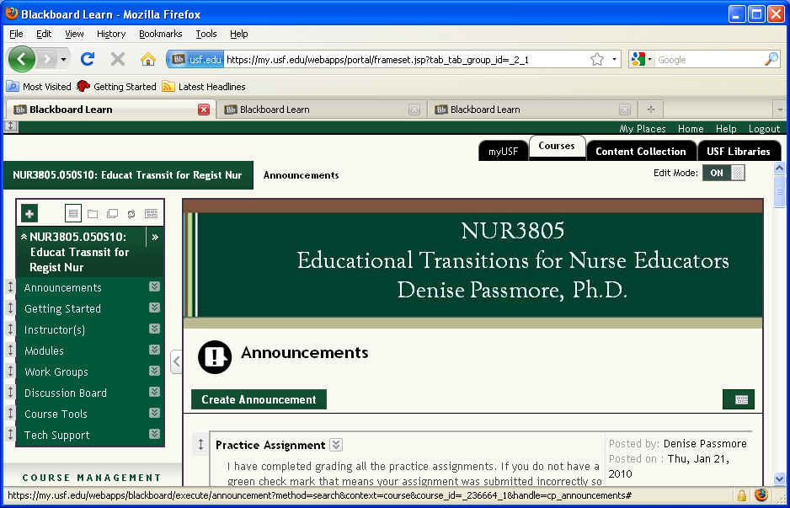
Select Discussion Board
Slide 2 - Slide 2
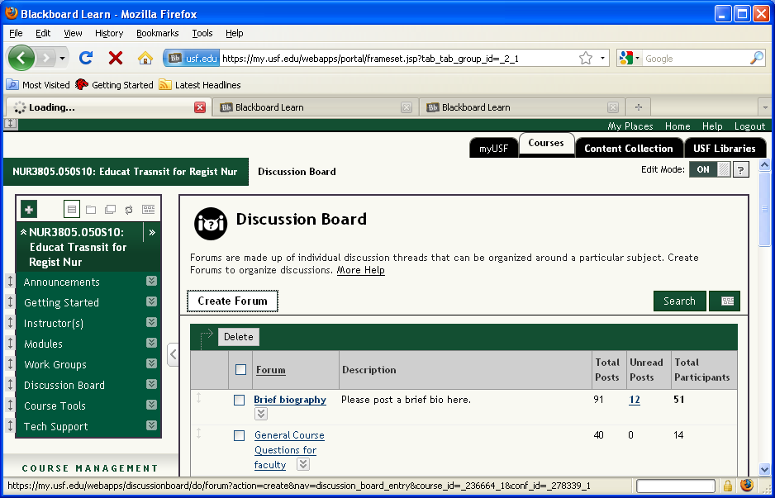

To add a discussion board, click Create Forum

Slide 4 - Slide 4
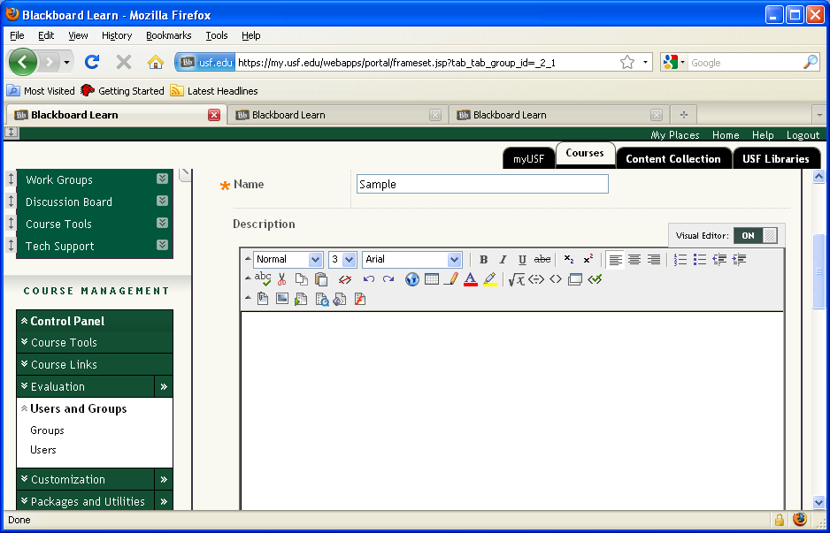

Enter a Name and if desired, a Description of the discussion board.
Slide 5 - Slide 5
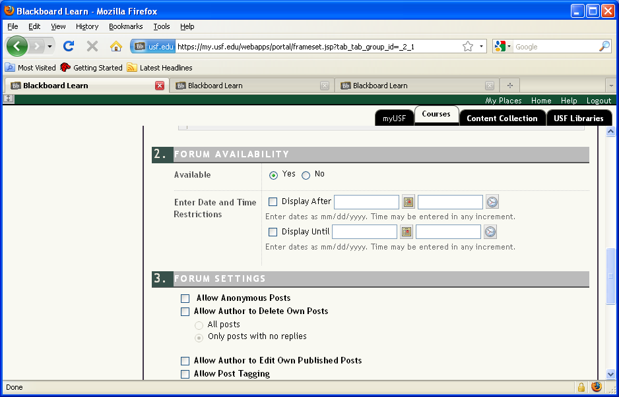

If desired, enter Date and Time Restrictions
Slide 6 - Slide 6
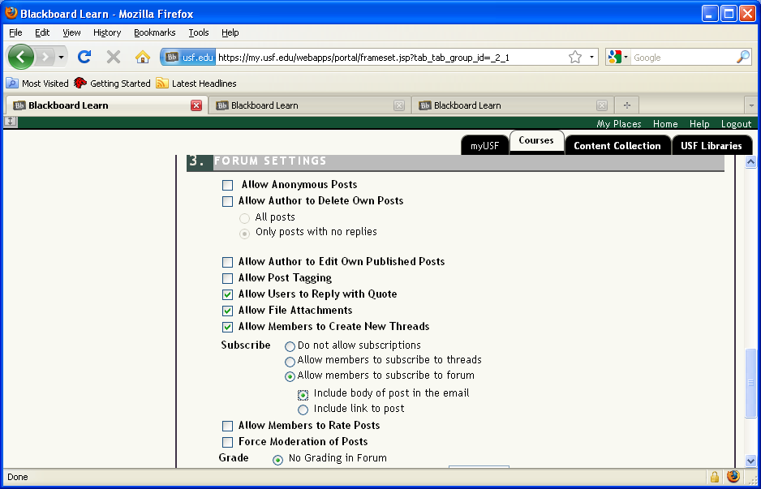

If desired, allow members to subscribe to the forum. If this option is selected, users can choose to Subscribe to the forum. This is particularly useful for Q&A discussion boards so that you will be notified if there are questions.
Slide 8 - Slide 8
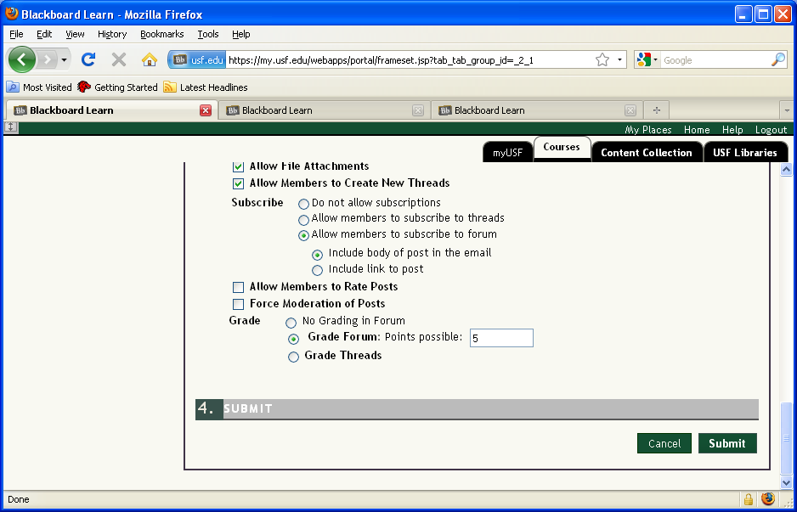

If this is a graded discussion board, select Grade Forum and enter the points possible. This will then appear in the grade center. If you want it to be complete/incomplete only, enter a 0 here then adjust the entry in the grade center.
Slide 9 - Slide 9
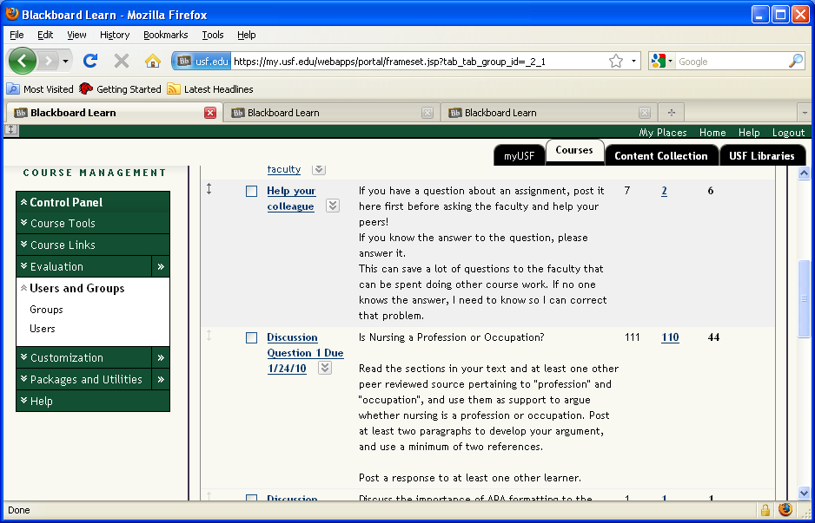

To view and grade a forum, select the forum you are grading from the list of discussion boards.
Slide 10 - Slide 10
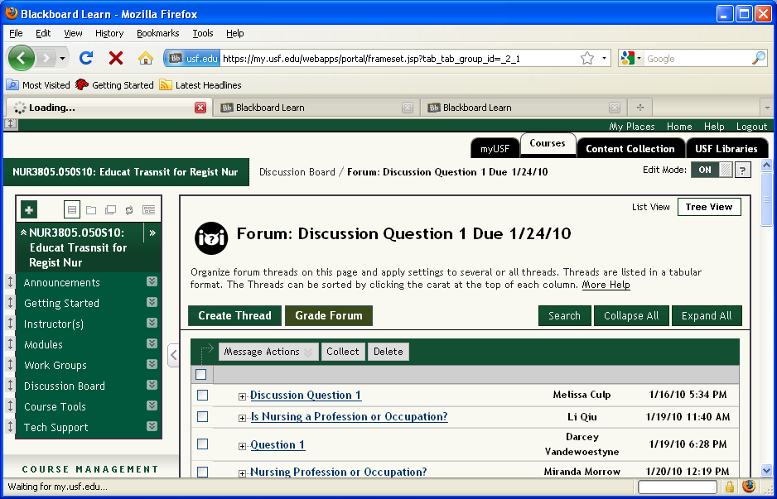

Click Grade Forum
Slide 11 - Slide 11
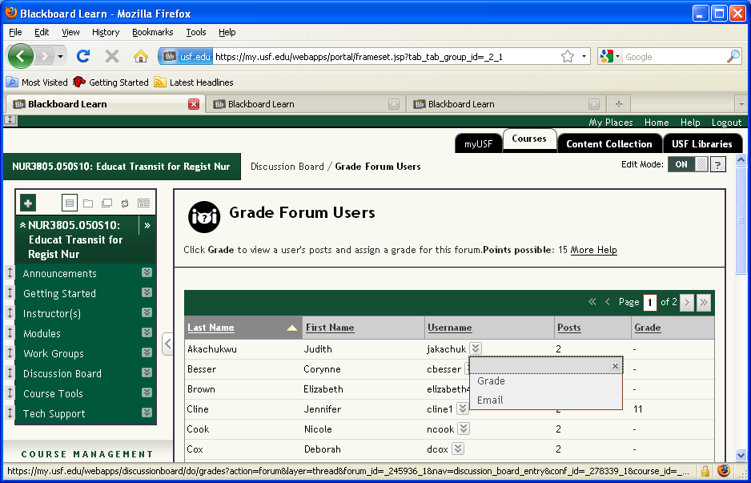

To grade a student, click the drop-down box next to their name and select Grade.
Slide 12 - Slide 12
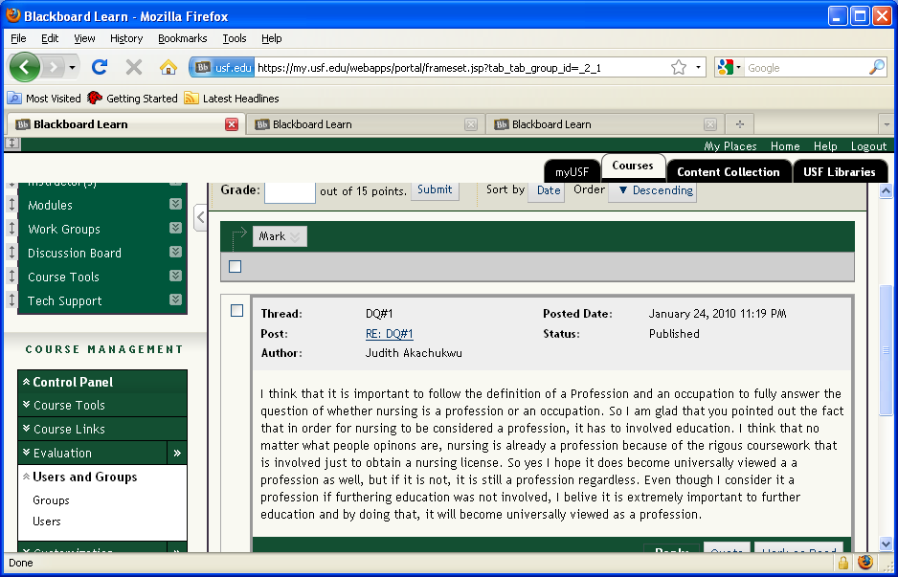

All posts by the student display.
Slide 13 - Slide 13
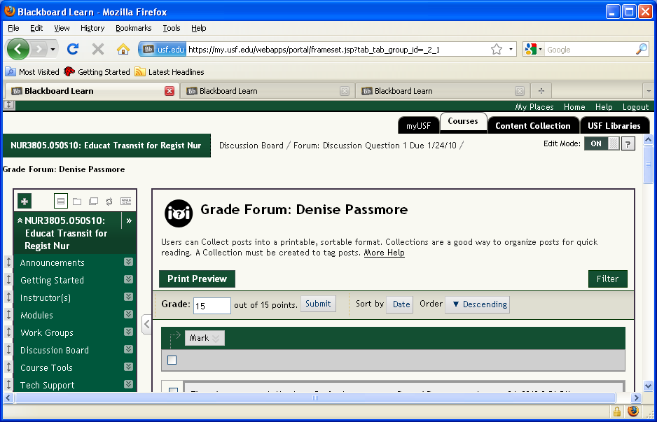

Enter the grade for the student and click Submit.
Slide 14 - Slide 14
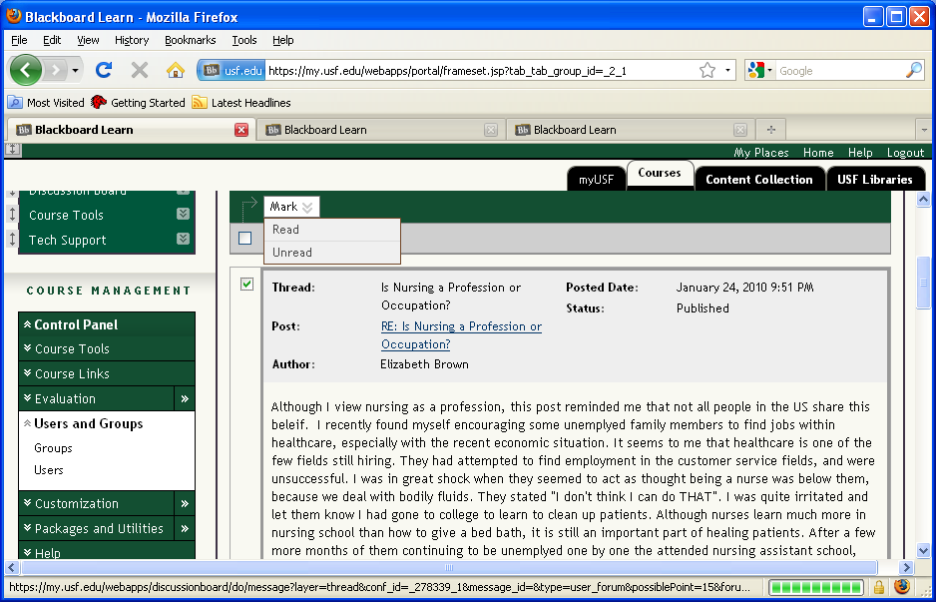

To mark these posts as read, click the boxes next to each posting and then select Read from the Mark drop down box.
SETTING AND AND USING SMART VIEWS

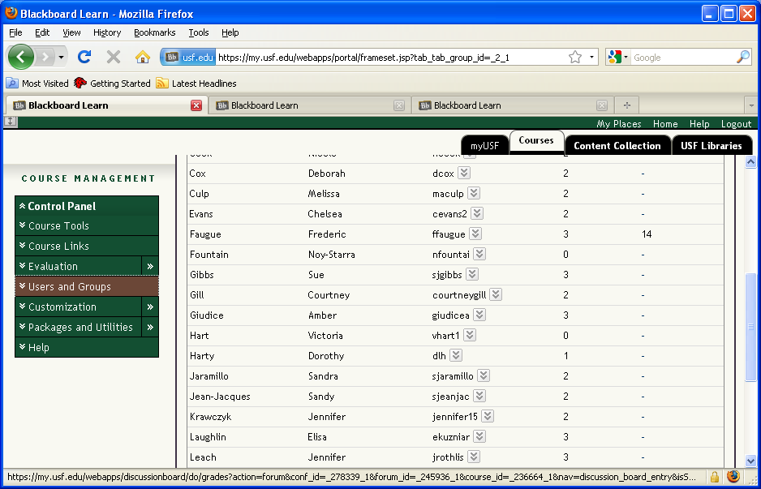

From Course Management, select Evaluation
Slide 16 - Slide 16
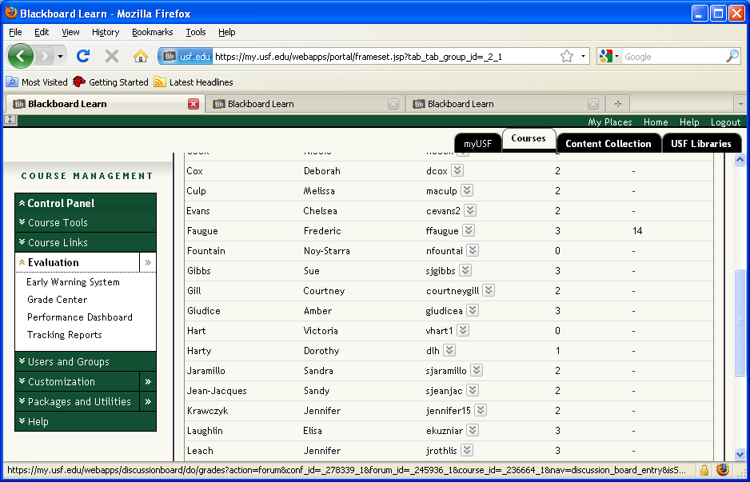

Click Grade Center
Slide 17 - Slide 17
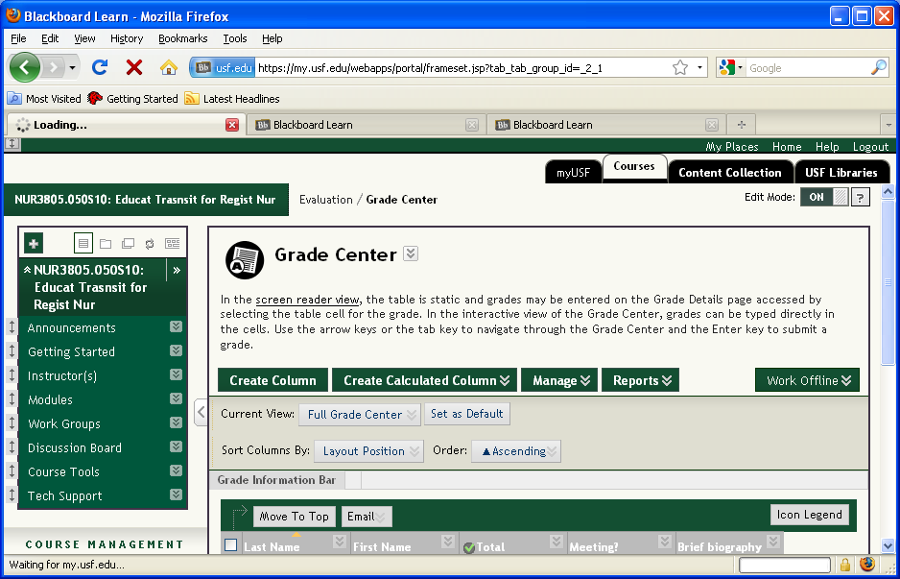

From the Manage Drop-down window, select Smart Views.
Slide 18 - Slide 18
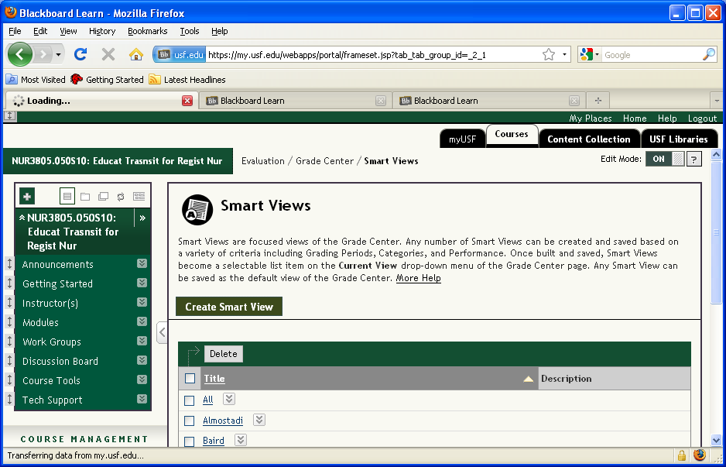

To set up a Smart View, click Create Smart View
Slide 19 - Slide 19
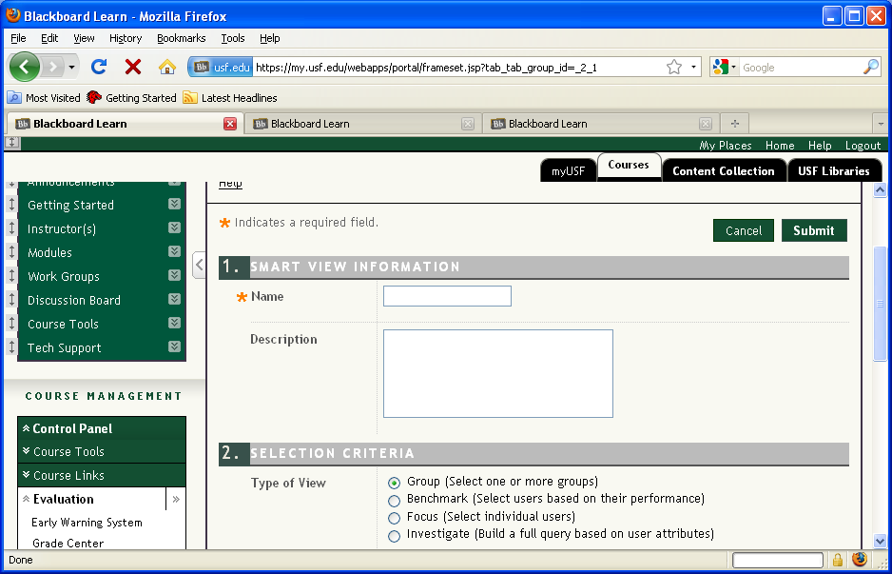

Enter the name and if desired, a description of the view. Use the selection criteria identified here to forcus your smart view.
Slide 20 - Slide 20
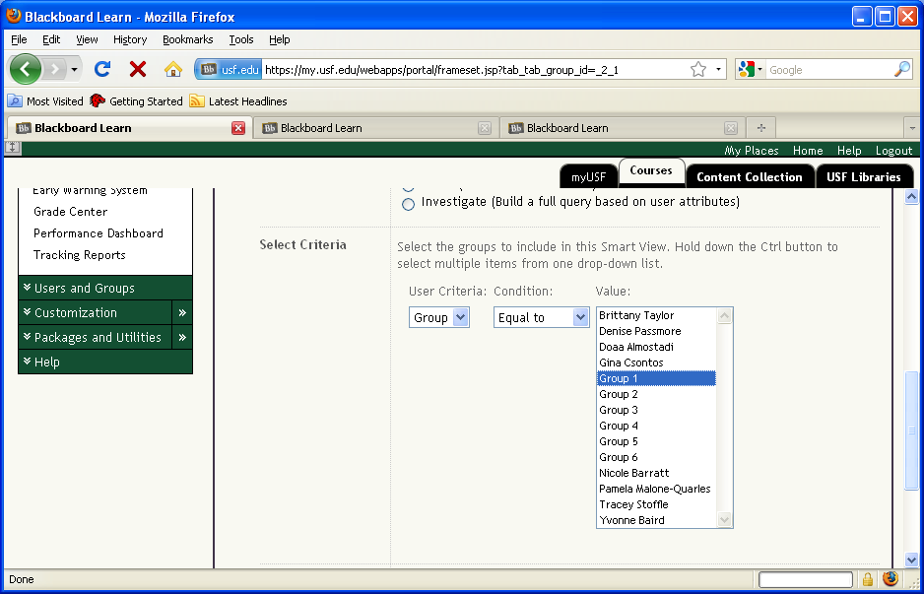

In this example, we are setting up a smart view by group, so we selected Group 1 as the value for the smart view. After making your selection, click Submit.
Slide 21 - Slide 21
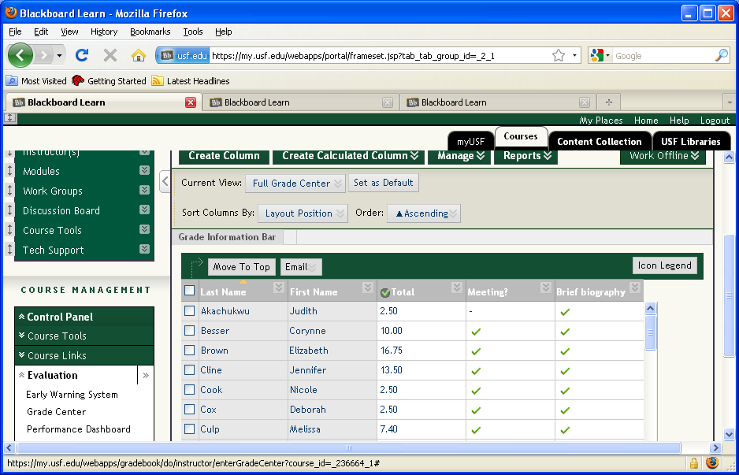

To view only the students in Group 1, mouse over the Current view: (Note the default is Full Grade Center)
Slide 22 - Slide 22
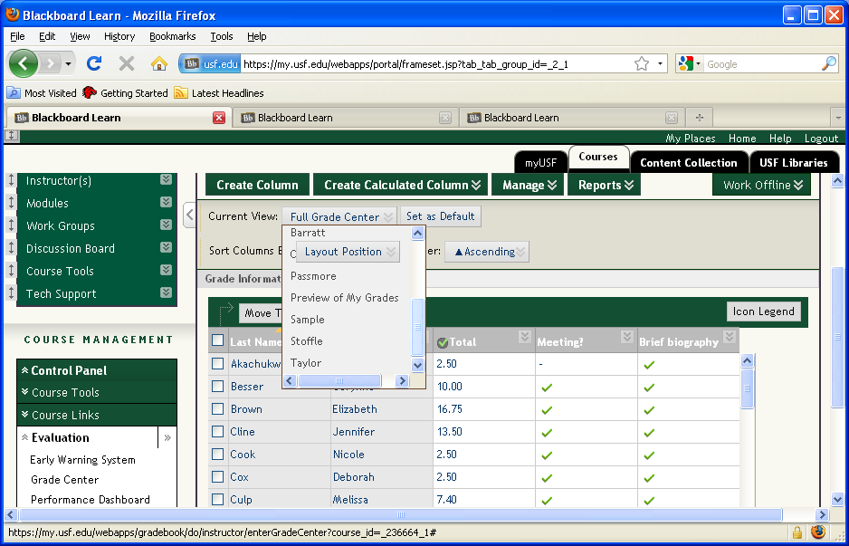

From the list of smart views, select the view you want (In this example, it is Sample).
Slide 23 - Slide 23
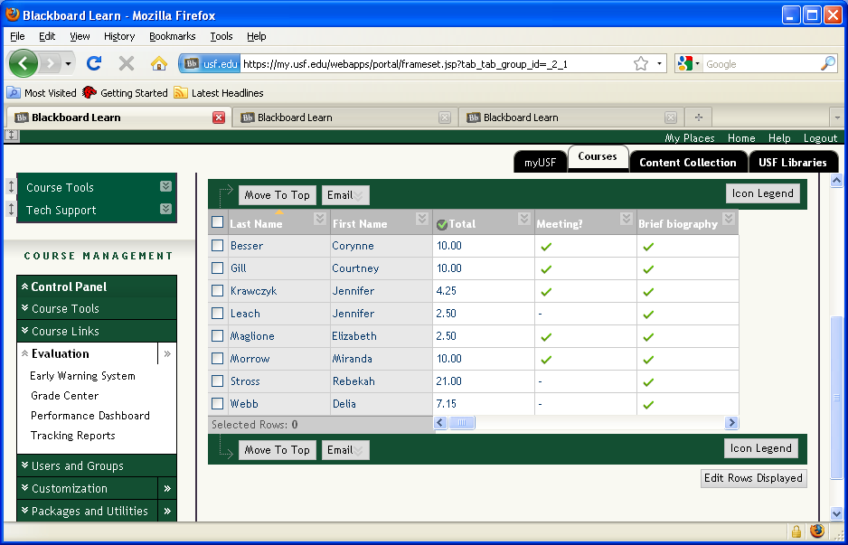
Now only the students identified in Group 1 display in the grade center.

